Social Media Assets for WNTD Campaign 2025
Title: Unmasking the Tobacco Industry’s Appeal, Demanding Accountability for Its Harms

Hashtags: #TobaccoExposed #WorldNoTobaccoDay2025 #BigTobaccoLies #ProtectYouthHealth

Partners to tag:
GYV
Facebook : @GlobalYouthVoices (https://www.facebook.com/GlobalYouthVoices/ )
Instagram : @GlobalYouthVoices (https://www.instagram.com/globalyouthvoices/ )
X : @GYV_movement (https://x.com/GYV_movement )
Linkedin : https://www.linkedin.com/company/gyv-global-youth-voices/

GGTC
Facebook : @TheGGTC (https://www.facebook.com/TheGGTC/)
Instagram : @theggtc (https://www.instagram.com/theggtc/)
Twitter (X): @GYV_movement (https://x.com/TheGGTC)
LinkedIn: @The GGTC (https://www.linkedin.com/company/79522647/admin/dashboard/)

Caption | Artcard
It’s not a vibe — it’s a trap. Tobacco’s clean look hides a dirty truth.  We’re exposing the design behind addiction.  #WorldNoTobaccoDay #HookedByDesign #UnmaskTheAppeal #MakeThemPay​ | 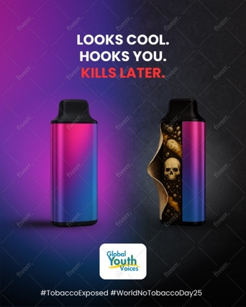
3 Shocking Truths Big Tobacco Doesn’t Want You to Know:  🚭 50 million teens addicted  💨 15000+ flavours flood the market  🌍 4.5 trillion toxic plastics pollute our environment yearly  It’s not just addiction—it’s exploitation. It’s time to make them pay.  #UnmaskTheAppeal #WNTD2025 #YouthAgainstTobacco​ | 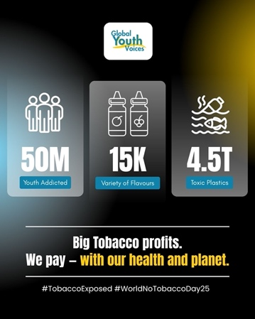
Big Tobacco traps youth with flavor, fame, and fake “eco” image.  We’re unmasking the appeal—and demanding justice.  Swipe to see how youth are fighting back and how governments must step up.  #WNTD2025 #MakeThemPay #YouthAgainstTobacco #UnmaskTheAppeal​ | CAROUSEL POSTS  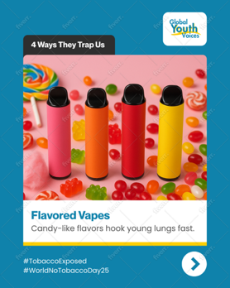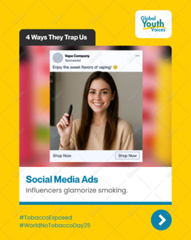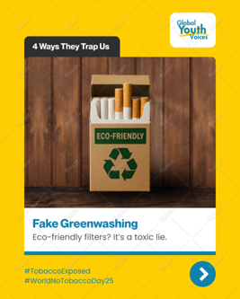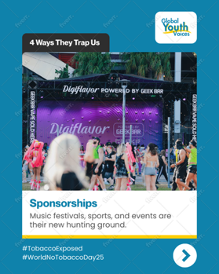  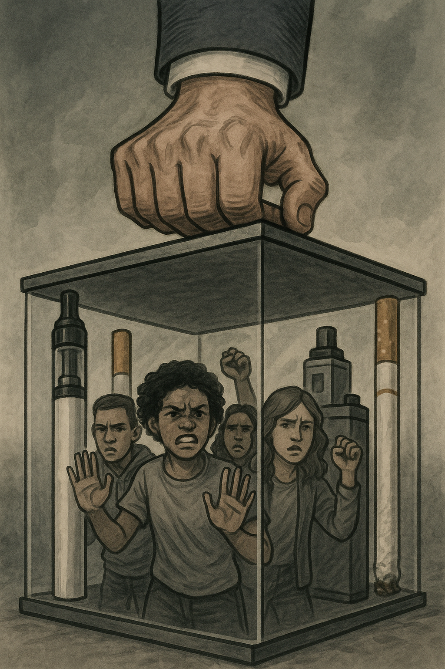  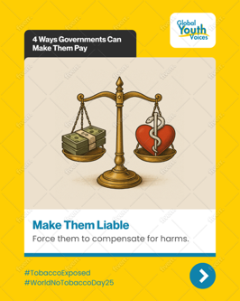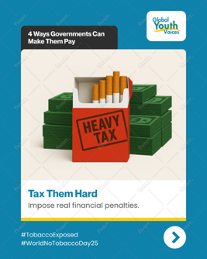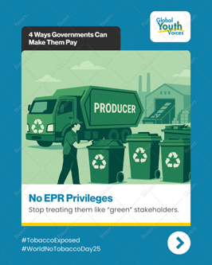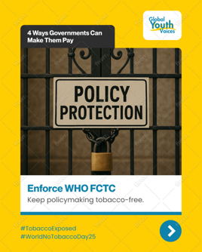  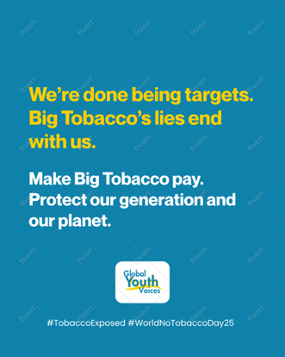
We’re done being targets. We demand truth, justice, and action.  Join our movement. Unmask the Appeal.  #GlobalYouthVoices #WNTD2025 #YouthLeadChange​ | GENERIC QUOTE CARD CUSTOMIZED QUOTE CARD  